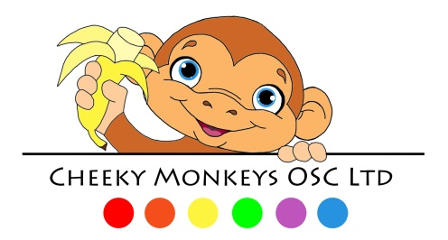
Cheeky Monkeys OSC
Risk Assessment Policy

We ensure that Cheeky Monkeys is a safe environment for your child.
The Statutory framework for the Early Years Foundation Stage sets out legal requirements that all providers must meet. This includes requirements relating to risk assessments. Providers must have a policy and procedures for assessing risks and must carry out risk assessments in two circumstances. These are in relation to:
- the environment (paragraph 3.63 of the Statutory framework)
outings (paragraph 3.64 of the Statutory framework).
We risk assess all furniture, rooms and resources to ensure the club is safe for children and adults at all times. We ensure that all activities are safe for the children and that the indoor and outdoor environments are checked for any risks before opening and closing the club.
Our risk assessment procedures are part of a continuous process to prevent any dangerous incident taking place. They are the responsibility of all staff as part of their daily duties.
See also Risk Assessment for Outings Policy.

This policy was adopted by: | Date:
To be reviewed: | Signed:

